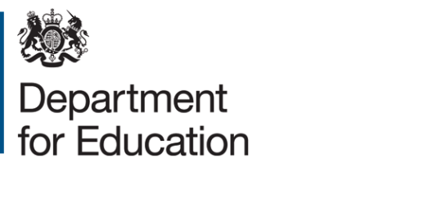

**APPROVAL UNDER SECTION 37(3) (b) OF THE**

**CHILDREN AND YOUNG PERSONS ACT 1963**

**IN RESPECT OF**

**MUSIC FOR YOUTH**

In pursuance of the powers conferred by section 37(3) (b) of the Children and Young Persons Act 1963, the Secretary of State for Education approves:

**MUSIC FOR YOUTH**

for the purposes of section 37 in respect of any performances under arrangements made by Music for Youth in England for a period from 6 March 2022 until and including 16November 2022.

**Signed on behalf of the**

**Secretary of State for Education**

**Jennifer Benjamin**

**Senior Civil Servant 28 February 2022**