Together for Music
Schedule of the Day
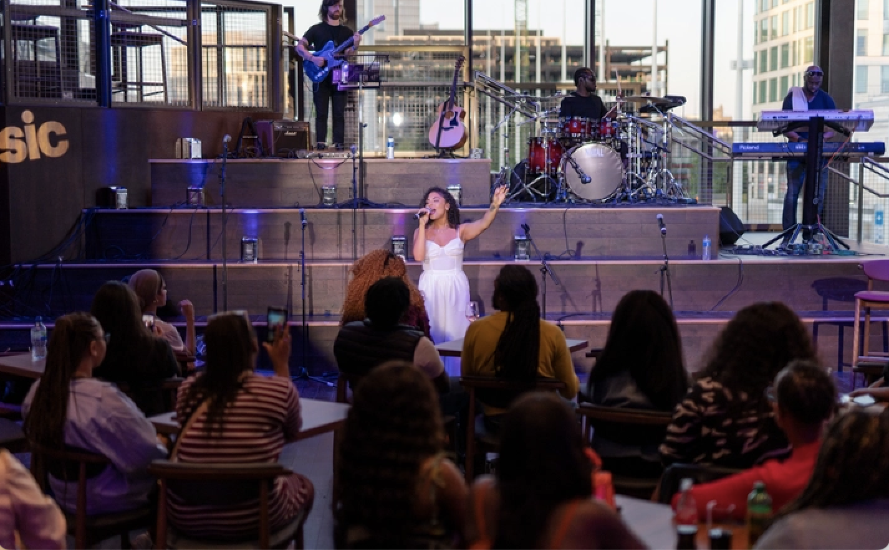 | Jennifer Blackwell Performance Space, Level 4
 | Music  10am-12pm  There will be young people performing music in the Jennifer Blackwell Performance Space.
The musicians performing are:

- Middlesbrough Open Orchestra
- Victoria School Choir
- Alfreton Park School
- The Hamilton Open Orchestra
Music
1pm-3pm

More musicians will perform in the Jennifer Blackwell. performance Space.
The musicians performing are:
- Rubik's Cube
- Chapman Sum
- Solihull Music
- Stratford Girls’ Chamber Choir
- Ashleigh and Lily
 | At 3pm, the event ends and everyone will leave Symphony Hall

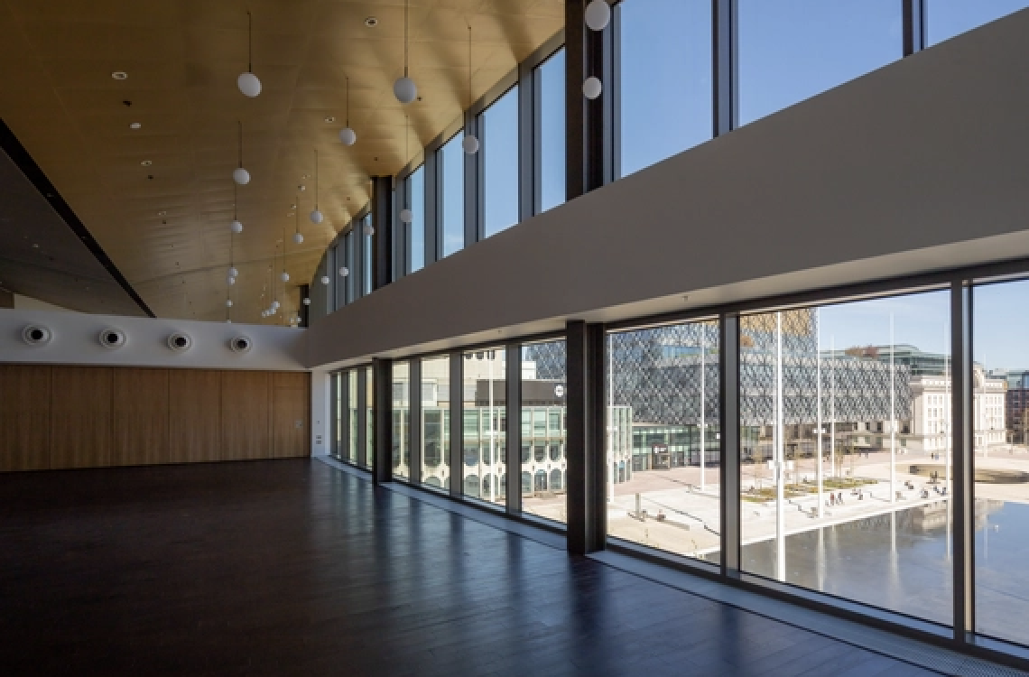 | Justham Family Rooms, Level 5a
 | There will be workshops you can join in the Justham Family Room
 | In the workshops you will play music with other young people.
 | There will be lots of instruments for you to play.
 | Workshop 1  11am-12pm  The first workshop will be in the morning for one hour.
Workshop 2
1pm - 2pm

The second workshop will be in the afternoon for one hour.

 | At 2pm, the workshops end and everyone will leave the Justham Family Room

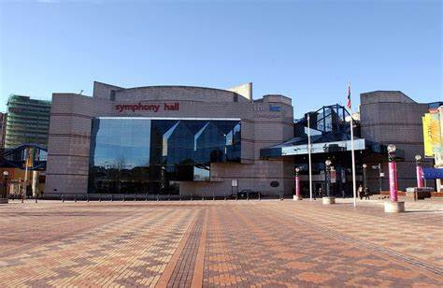 | Foyer, Level 4  There will be a Marketplace
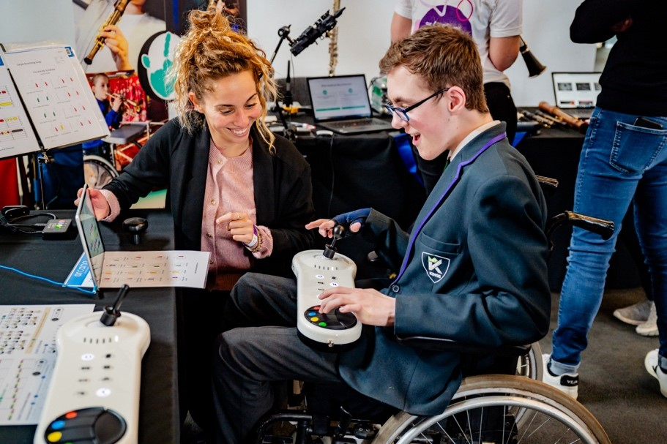 | You can visit the Marketplace all day.
 | There might be lots of people in the Marketplace.
 | There will be some accessible instruments for you to try.
There people behind the stalls are from music organisations.
They would like to share information about their work.
Some of the organisations at the Marketplace are:
- Music For Youth
- Trinity College London
- Ev-Entz
- Ohmi
- Open Orchestras

 | The Marketplace will close at 3pm.

B:Eats
The Cafe area at Symphony Hall
 | Music  12pm-1pm  You can watch a professional music performance and eat lunch here

