Welcome to Together for Music

What is Together for Music?
Together for Music is a festival of music, workshops, performances and activities at Bristol Beacon.

When is it happening?
Together for Music will take place at:
Bristol Beacon, Trenchard Street, BS1 5AR,
on Monday 18th March between 09:45-3PM.

Who will I see on the day?
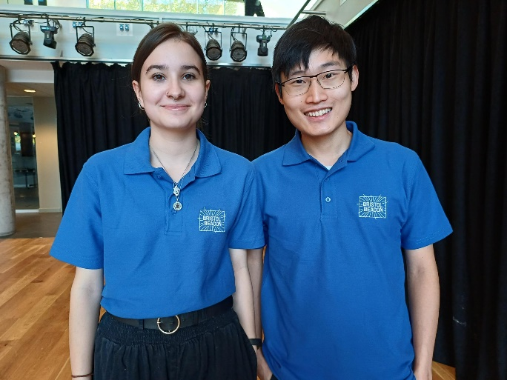
You will be greeted at our welcome desk by members of staff from Music for Youth and Bristol Beacon. They will show you where to go.
You will see our stewards around the venue. Our stewards will be wearing blue Bristol Beacon t-shirts.

You will also see other young people from schools who are watching and performing.
The venue is open to the public, so you will also see lots of other people enjoying their day. We have a café called Loaf at our venue, so you will also see people enjoying some food.

Where to come in?
You can come in either through Colston Street or Trenchard Street.
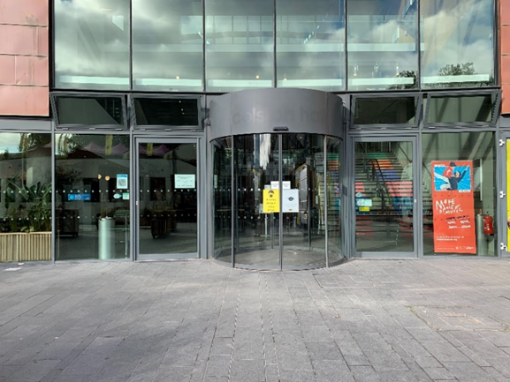
The door on Colston Street looks like this:

The door on Trenchard Street looks like this:
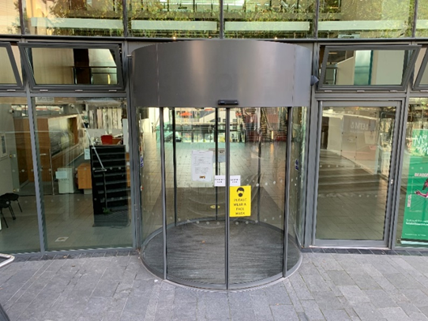

Our welcome desk will be on the Lower Ground Floor. To get here you can use the Colston Street entrance and the welcome desk will be directly in front of you. You can also use the Trenchard Street entrance and take the stairs to the Lower Ground or a lift.

How can I get there?
Bristol Beacon’s address is Trenchard Street, BS1 5AR.
There will be spaces for mini-buses to drop you off when you arrive.

What will I experience at Together for Music?
There will be lots of things to see and do at Together for Music.
There will be musical performances, including choirs, orchestras, singers and soloists, stalls to visit and music workshops.
There will be lots of people and sometimes it might be a little bit loud.

There will be quiet rooms that you can use if things get too noisy. Our stewards or staff at the Welcome Desk can help you find these.

Where is it taking place?
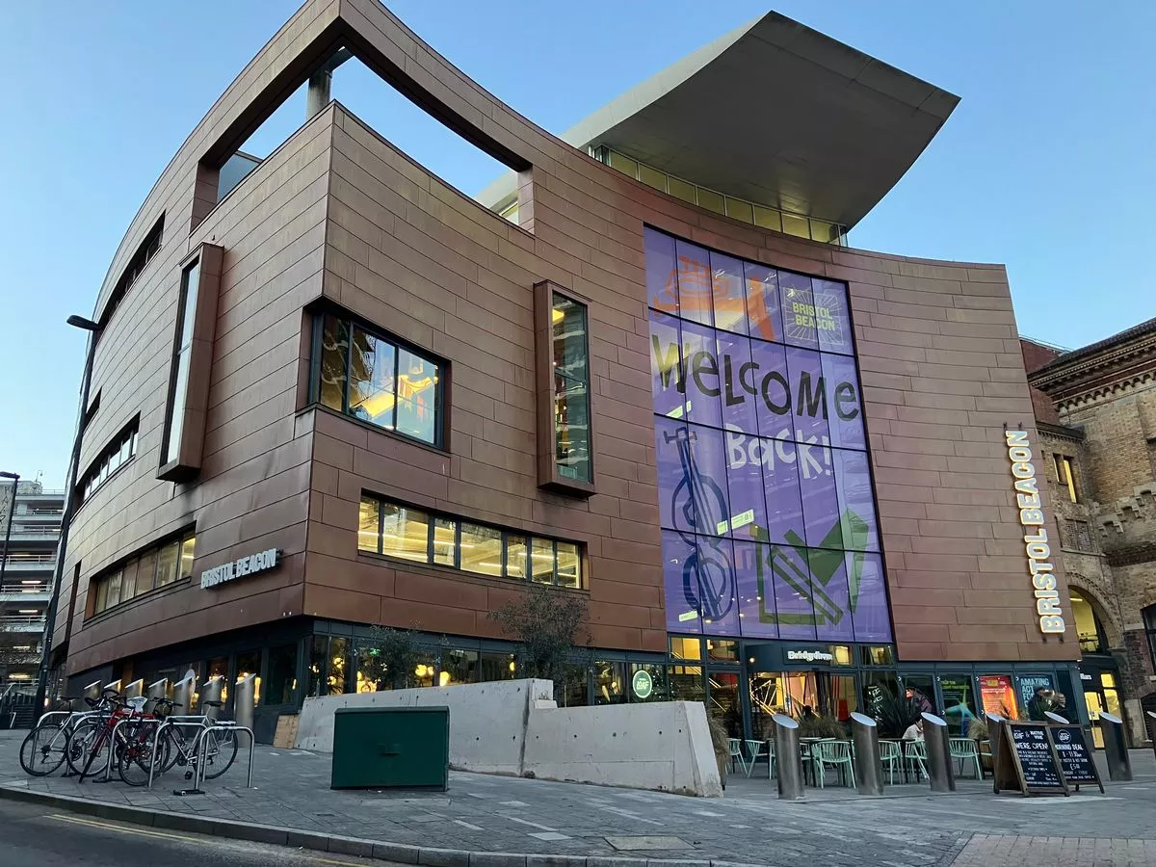
Together for Music will take place at Bristol Beacon. Bristol Beacon looks like this:

There will be six areas where things are happening for Together for Music.
These are:
- Lower Ground Floor – this is where our welcome desk will be. Trinity are also holding talks on this level.
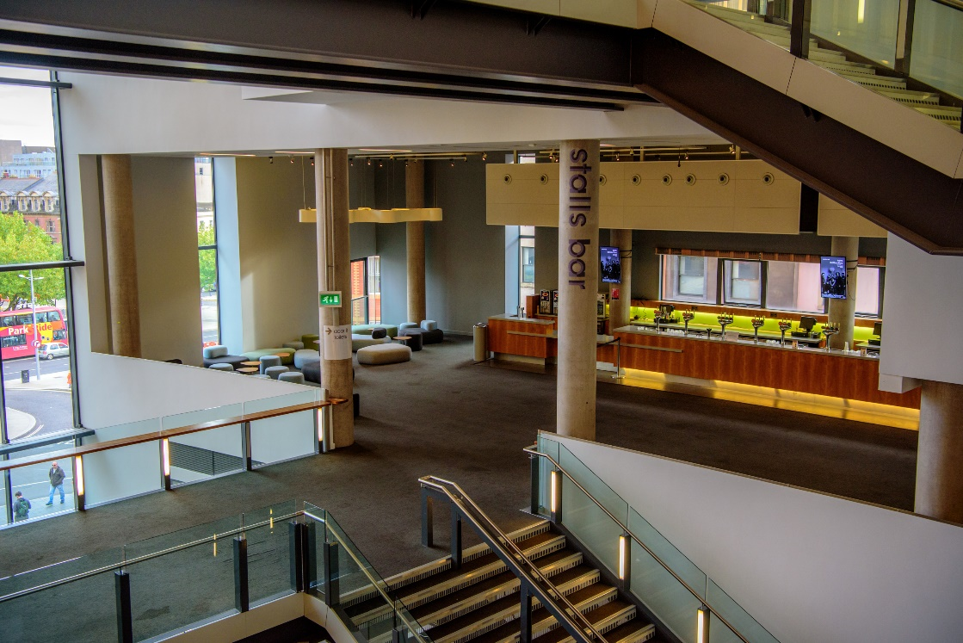
- Stalls Bar – This is on level one, where there will be tables with people and stalls at our Music Marketplace. The Stalls Bar looks like this
- Beacon Hall – You will enter Beacon Hall from level 1 and this is where the performances will happen. Here is a picture of Beacon Hall from the audience.
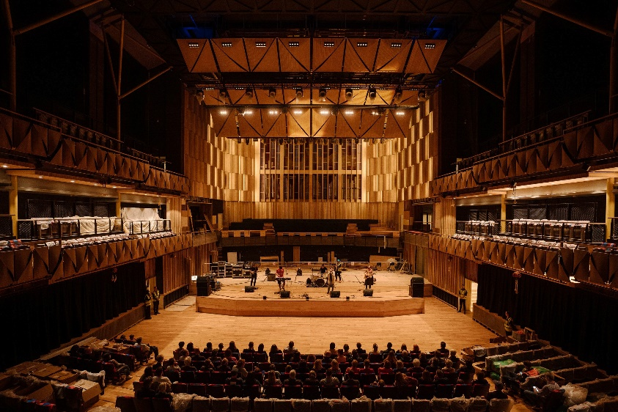

There will be amplified sound and some lighting changes in Beacon Hall.

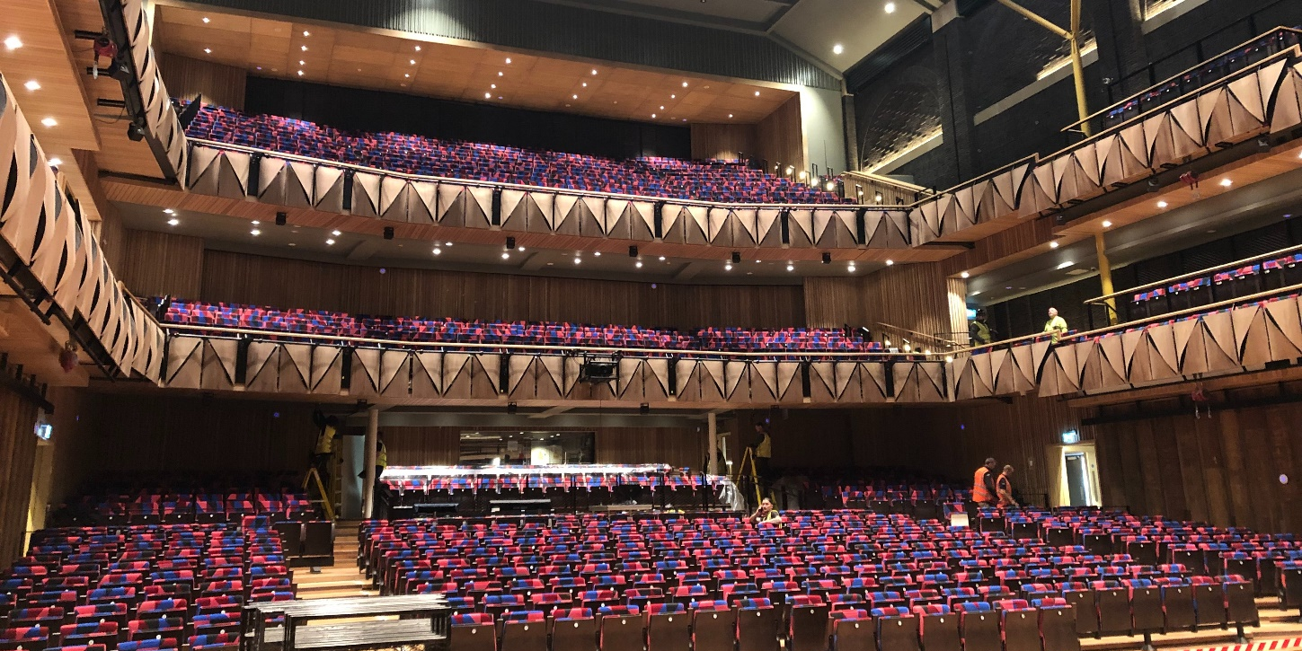
Here is a picture of Beacon Hall from the Stage.
- Lantern Hall - You will enter the Lantern Hall from level 1 and this is where the workshops will happen. Here is a picture of the Lantern Hall.
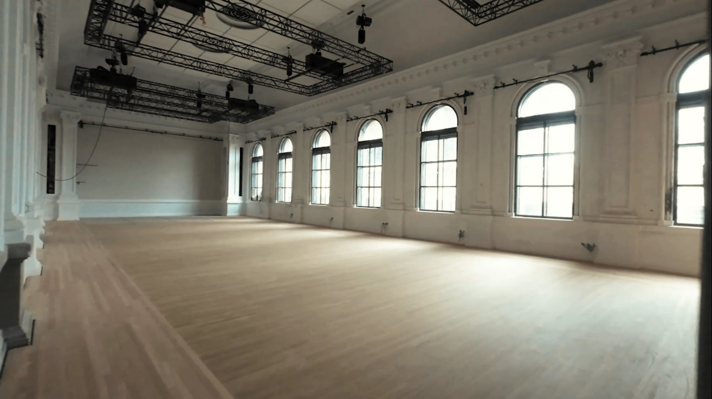

There will be some amplified sound and use of musical instruments in the Lantern Hall. There will be chairs in here for you to sit down.

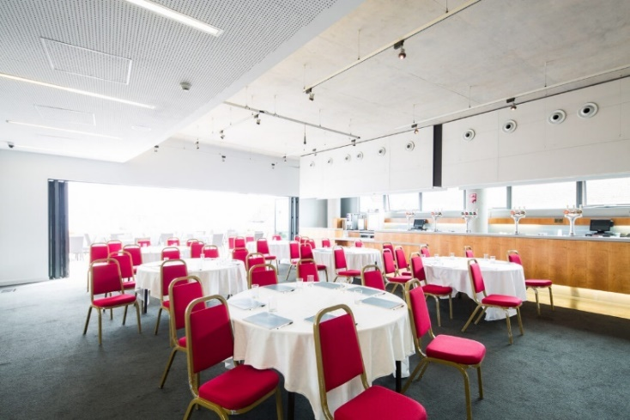
- The Terrace Bar – this is on level three and is where you might have your lunch. This is picture of the Terrace Bar with tables and chairs in it, it will be clear on the day.

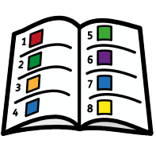
What can I do at Together for Music?
You will be able to see the programme for the day on screens in Bristol Beacon. In the programme you will find information about the different performances and activities, when and where they are taking place.
Here is what you can expect to happen on the day and some activities that you might want to take part in.

Welcome Desk | 9.00am-3.00pm, Lower Ground Floor
Musical Marketplace | 9:00am-3.00pm, Stalls Bar
Trinity Talks | 9:00am-3:00pm, Kennedy Room
Quiet Room(s) | 9:00am-3:00pm, Meeting Room 1 and 2
Lunch | 11:45am-2:00pm, Terrace, Level 3
Performance 1 | 9:45-11:45, Beacon Hall
Workshop 1 | 10.45am-11.45am, Lantern Hall
Performance 2 | 12:45-14:30, Beacon Hall
Workshop 2 | 12.45am-13.45am, Lantern Hall

Toilets
Our accessible toilet facilities are found on all levels and are signposted in the building.
Our Changing places toilet is located on the Lower Ground Floor. It looks like this:

We are looking forward to welcoming you to Bristol Beacon!
When something is new, this might make us feel a little nervous or anxious… and that is ok.

We might also feel happy or excited… that is all OK too.

We will have ear plugs (for children over 12 years) available at the Box Office, but you might want to bring your ear defenders.

If you need help on the day, ask one of our stewards or a member of staff at our Welcome Desk. Bristol Beacon staff will be wearing lanyards with yellow cards attached.
A BSL signed tour of the venue can be found here - https://youtu.be/_v9fc1GdgLU
A walkthrough video of the venue can be found here – https://youtu.be/iEDCWqNgADM
If you have any questions about Together for Music, please contact:
Elizabeth.connell@bristolbeacon.org
0117 204 7139

